**technical documentation for this task**

I use ASP.NET MVC 5 and Entity Framework Code First Approach

SQL Server Database and ASP.NET Identity for Authentication

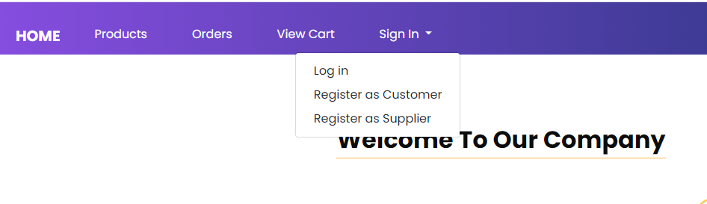

You Can Register as Supplier

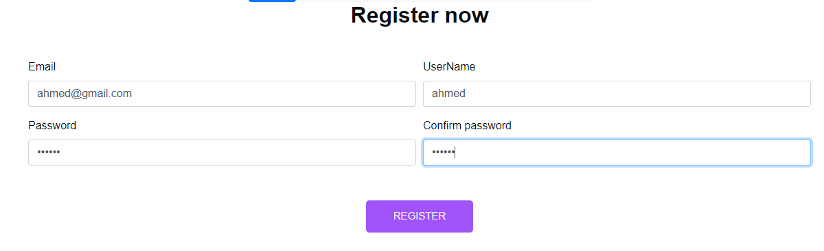In BackGround Take Supplier Role , and You Can Add Your Products



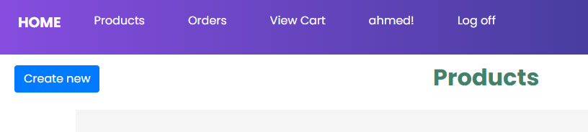

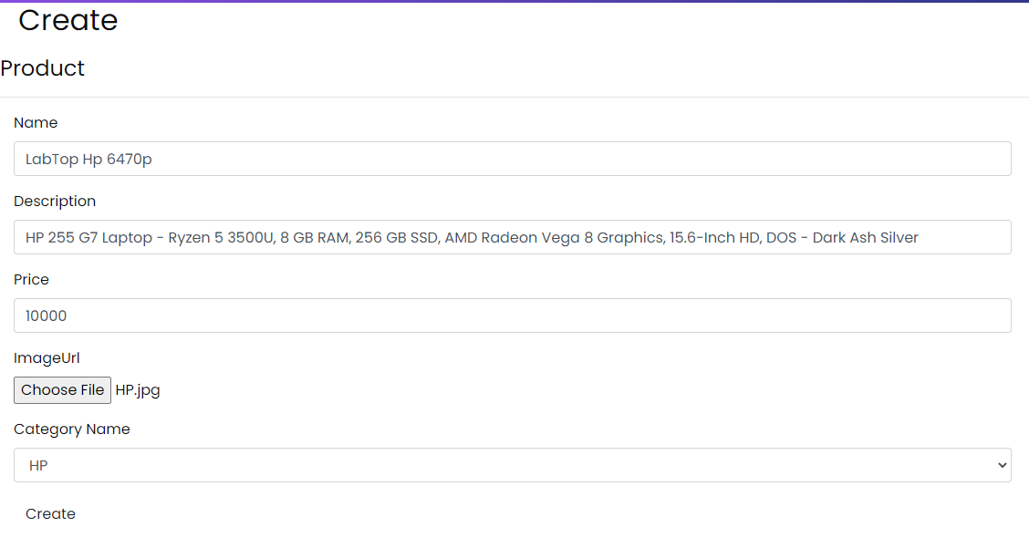

Now You Created Your Product, then Signout and Register Customer To Buy this Product

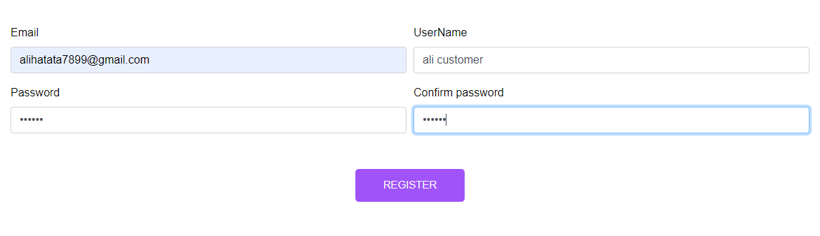Enter Your Customer Mail, you will receive the link of Invoice Pfd in this email

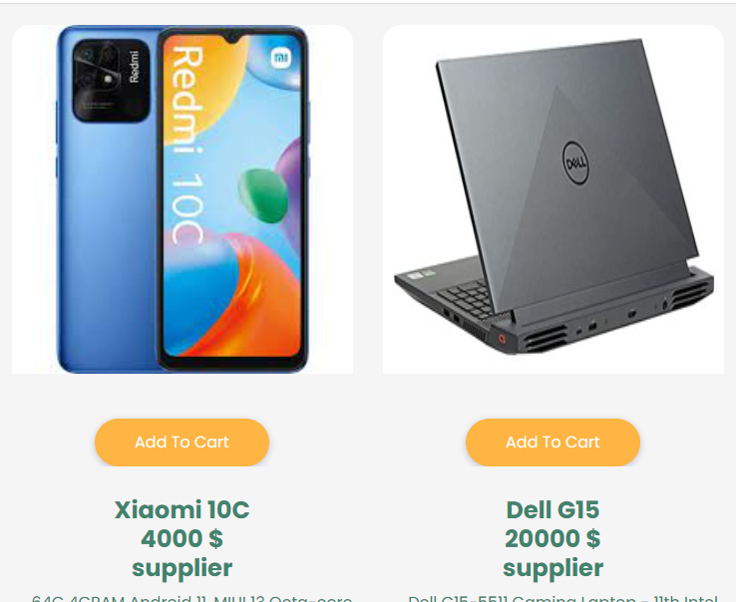

Now I will 2 Product to Cart for example (I Use AJAX Here for Performance)

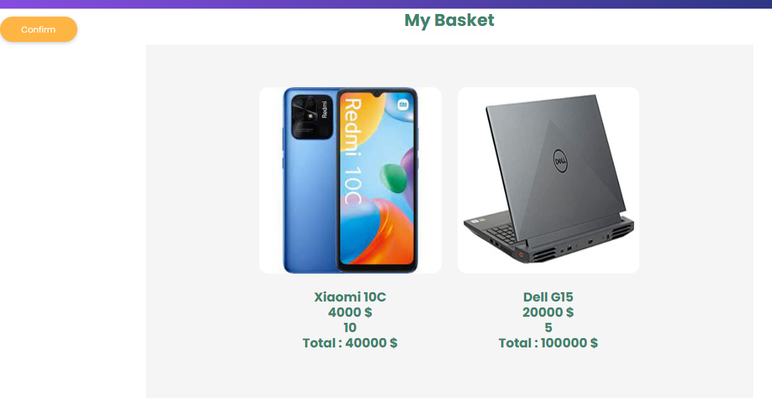

Now Click Confirm To Complete Your Order and ,you will receive message for your mail with the Invoice



Now you Receive On Your Mail The pdf Invoice

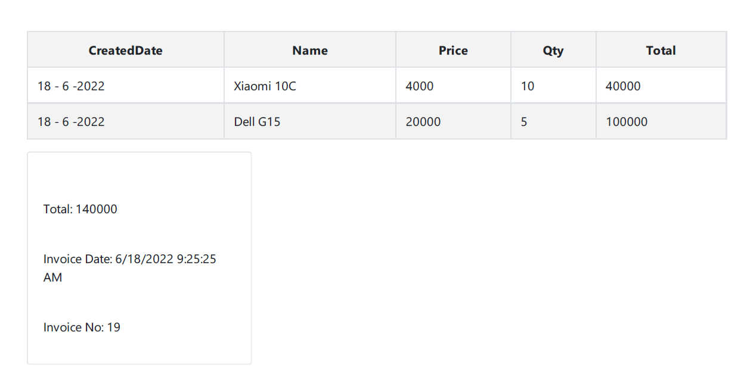

This is pdf Invoice

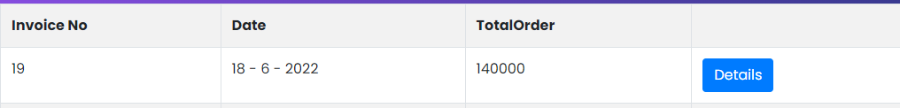

You Can Preview Invoice Detail from Here